**Results from updated resistance model**

Following the updates to the model by including splines (with 4 knots) to characterize non-linear relationships between time spent per cell and “distance-to-road”, I re-ran the resistance models. All models showed convergence (after 5000 iterations) and resulting beta coefficients varied by behavioral state (foraging/transit) and study site (N/S Pantanal).

Below, I will show ridgeline plots for the beta coefficients (without the intercept) and will also display the resistance surface for each State x Site combination only for pixels that were used by the armadillos. Additionally, marginal effects plots will be displayed to show the non-linear relationship of distance-to-road compared to time per cell.

North Pantanal

*Foraging*

For the foraging state, distance to road (as denoted by the splines) appeared to show the greatest influence on armadillo movement. All other variables did not appear to influence time spent per cell while in the foraging state at the northern site.

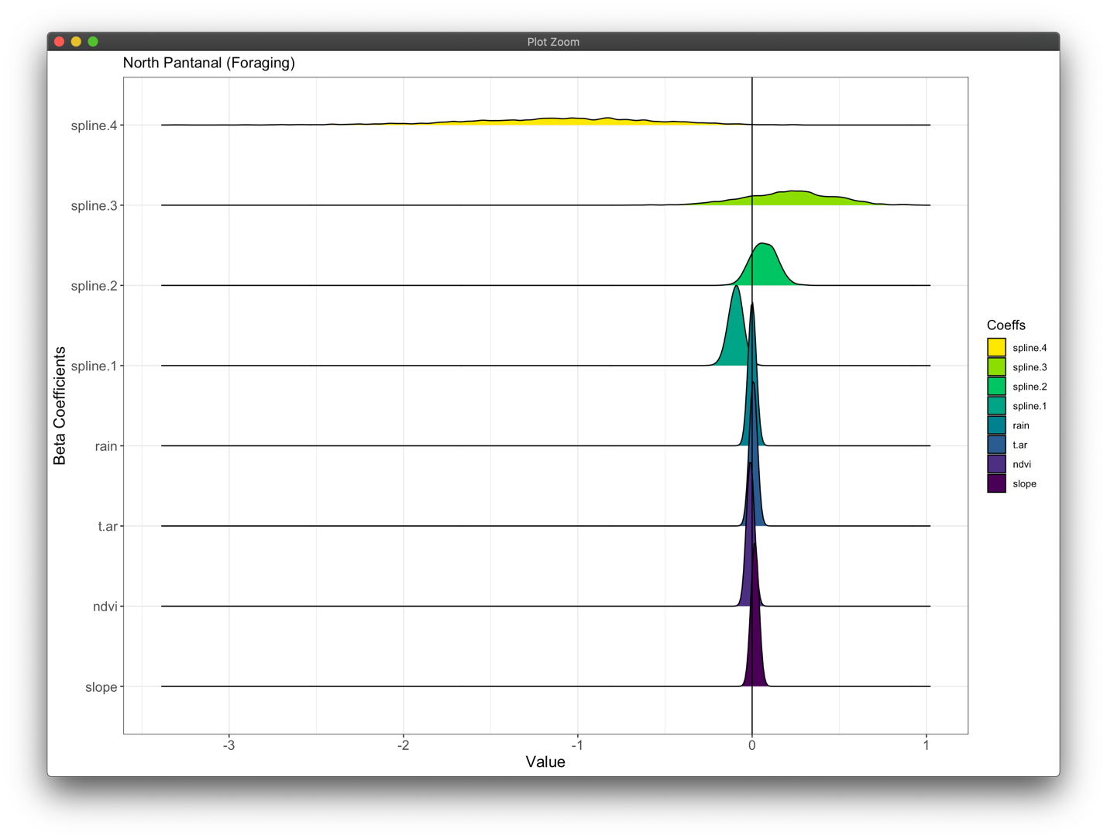

The effect of temperature (“t.ar”) is shown in this facet plot of landscape resistance, where the effect based on the minimum, mean, and maximum temperatures are displayed. In general, there does not appear to be a strong effect of temperature on foraging movement as was also found in the previous plot. Although the relationship between time spent per cell and distance-to-road was non-linear, there did not appear to be much difference until the armadillos were further from roads than on average (> 0), after which time spent per cell appeared to increase and then rapidly decrease. This is likely an artifact of the few points that were measured that far away from the roads.

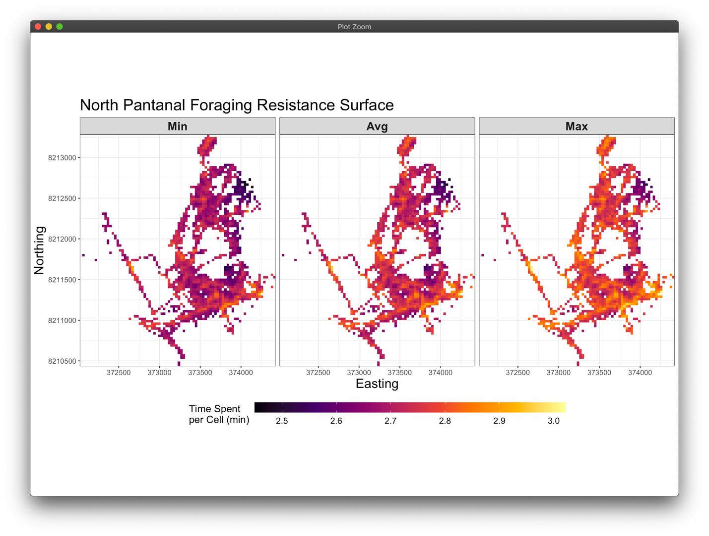

*Transit*

Transit movements were most influenced by distance-to-road (as characterized by splines), followed by temperature and NDVI. Temperature showed a positive relationship with time per pixel, whereas NDVI displayed a negative relationship.

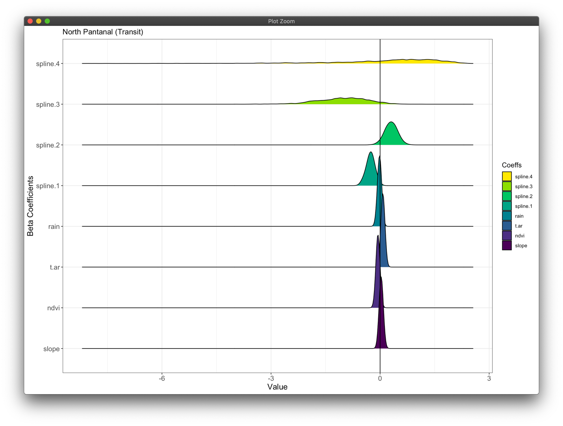

For the transit state, the strong effect of temperature is observed over the landscape of used pixels, for which there is approximately a 50% increase in time per pixel when comparing minimum vs maximum temperature conditions. This resistance surface also appears to show that armadillos spend more time per pixel on roads vs off-road, which could be a result of some behaviorally confounding factors. A marginal effects plot of the relationship between time spent per cell and distance-to-road was relatively linear apart from the greatest distances, also a likely result of few observations this far off the roads.

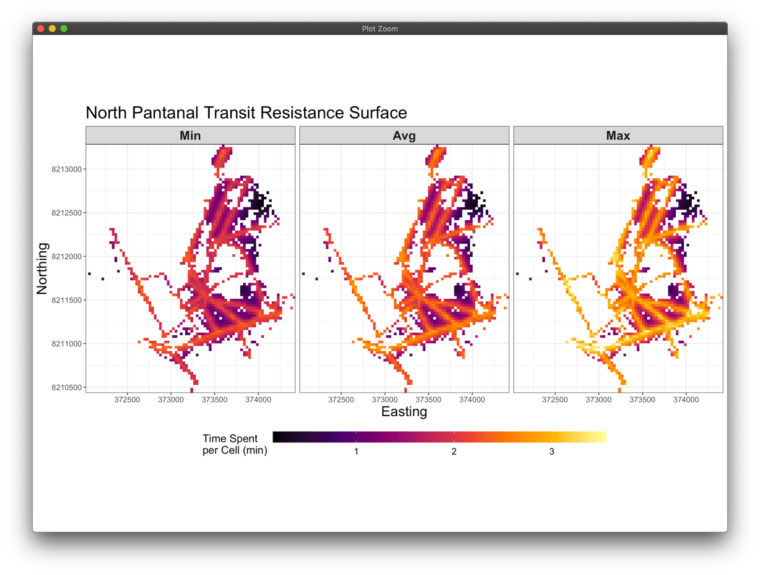

South Pantanal

*Foraging*

None of the covariates had a strong impact on landscape resistance (all very low beta coefficients), which reflected the same results for the foraging state from the northern site.

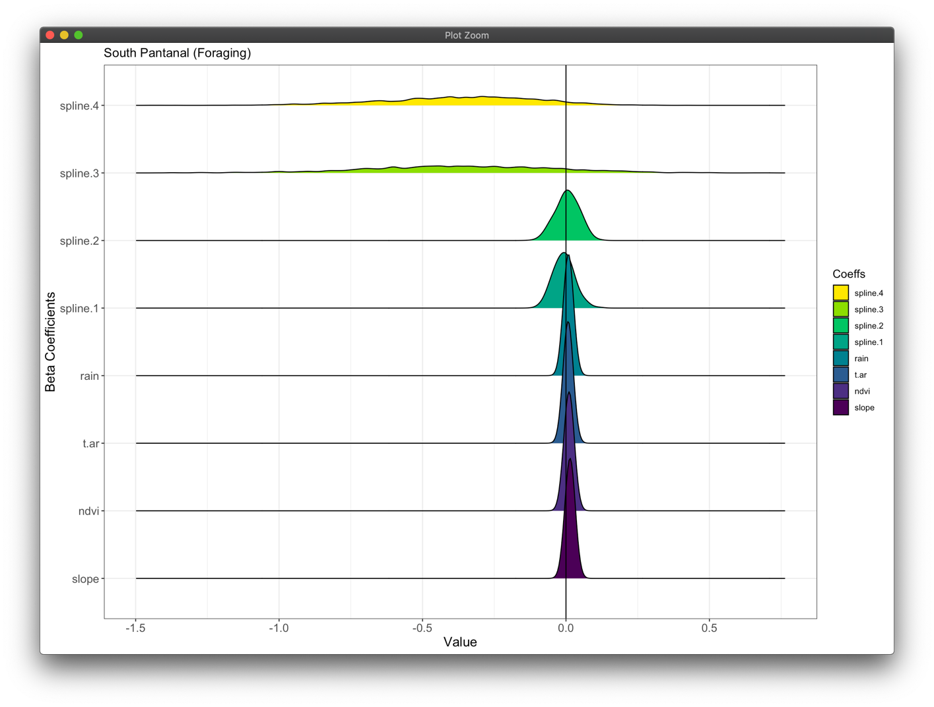

As can be seen in this figure, there is very little effect of temperature on movement and resistance is primarily dictated by distance-to-road, particularly at the greatest distances. Based on the marginal effects plot of time vs distance-to-road, there’s a similar relationship as was seen for the foraging behavior at the northern site. This demonstrates little effect of distance-to-road on time spent per cell while foraging unless very far off-road, but even this response is highly variable.

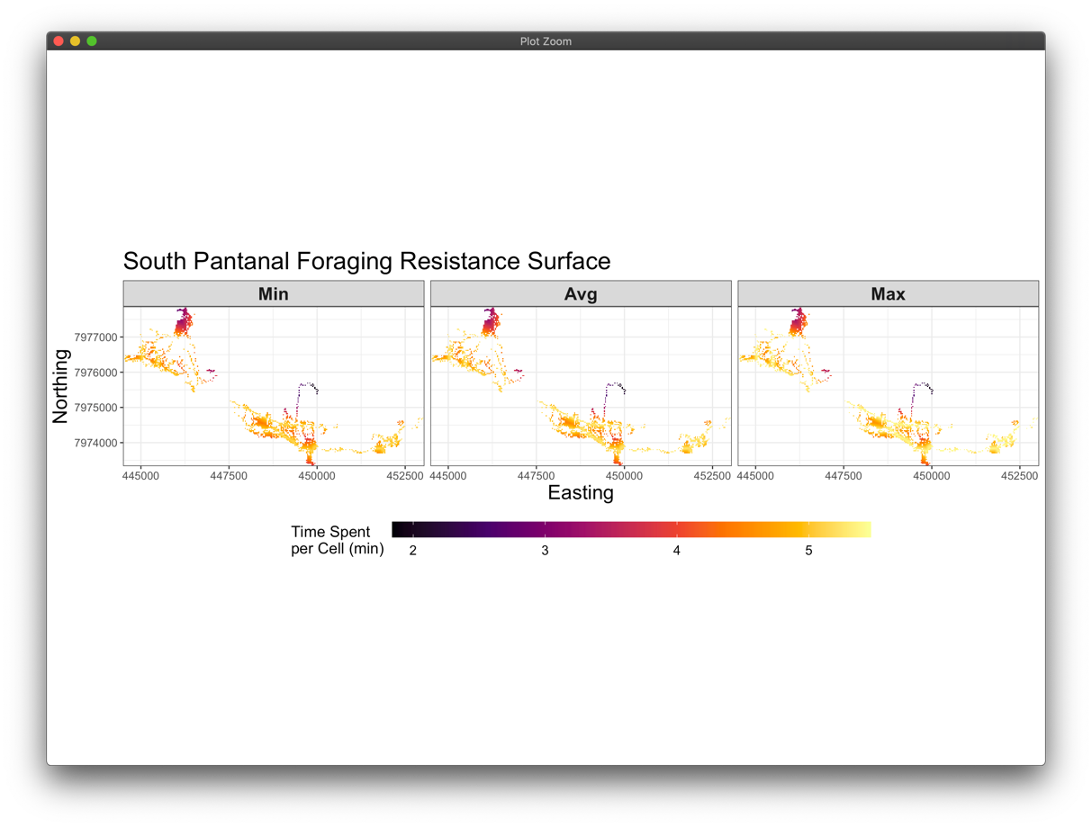

*Transit*

Transit movements of southern Pantanal armadillos were very strongly influenced by NDVI, temperature, rainfall, and distance-to-road. NDVI exhibited a negative relationship with time spent per pixel, whereas temperature and rainfall both displayed positive relationships.

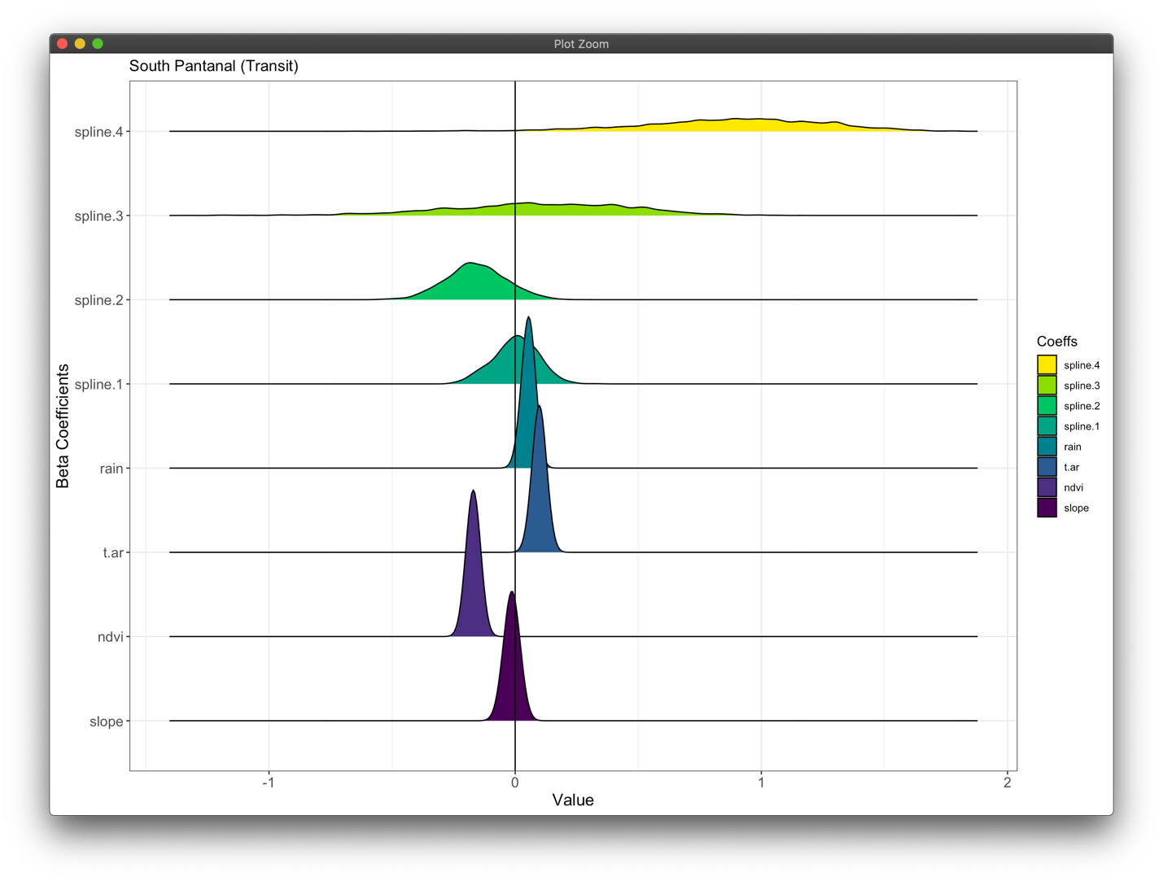

This resistance surface for transit movements shows a relatively large amount of variability in time spent per pixel, which is partly affected by changes in temperature. Effects of NDVI and distance-to-road can also be seen in these plots, although the relationship between time and distance-to-road actually appears to be the opposite of that found for the transit state of the northern site. This difference can be partially explained when visualizing the marginal effects plot, where at the greatest distances from the road, armadillos are expected to spend much more time per pixel than when closer to roads.

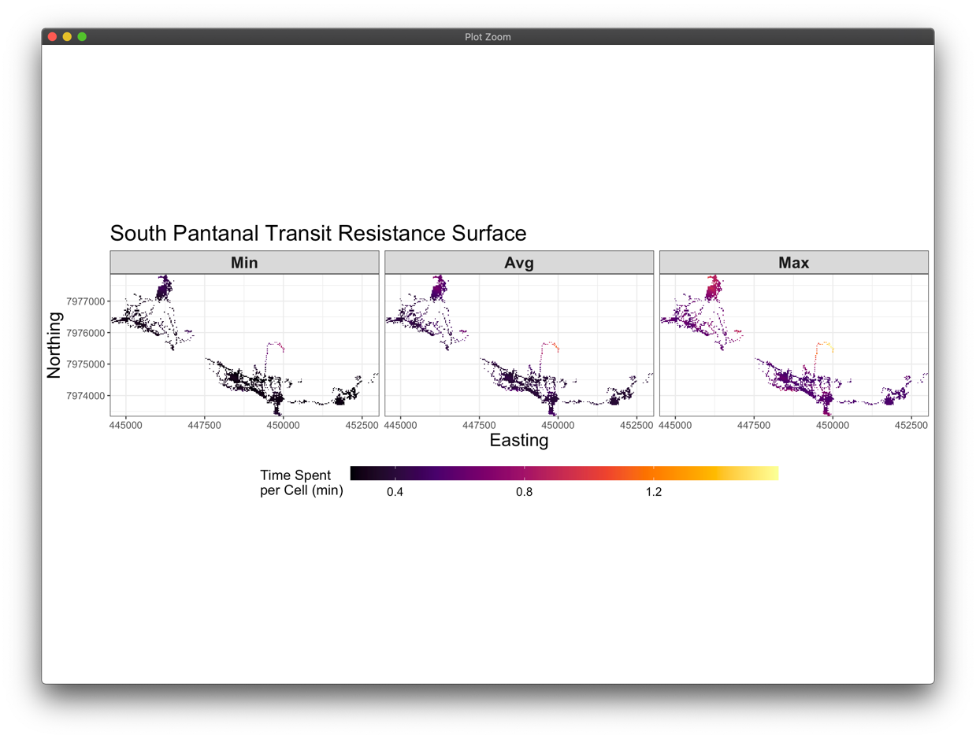

**Conclusions**

Based on the results from both sites, it appears that foraging “resistance” (or possibly more apt is foraging time/investment) does not show strong differences at this given spatiotemporal scale. Variability in “foraging investment” only ranged at most by 30 s per pixel at the North site, but up to 3 min at the South site. This large range for the South site appears to be related to the effects of distance-to-road, possibly highlighting greater foraging opportunities at these locations far from the road.

Resistance of the transit movements were more strongly influenced the environmental covariates, primarily NDVI, temperature and distance-to-road. These results show that lower NDVI values (or vegetation cover) and lower temperatures result in faster movement across the landscape, which is in line with expectations based on communications with Nina. However, the effects of distance-to-road were slightly different between sites. At the northern site, there appeared to be a slight hump in time spent per pixel for distance-to-road values near the average, whereas this was not present for the southern site. Additionally, time increased at a greater rate for the furthest distances from the road compared to the northern site. Since these differences are still relatively unclear, this should be investigated further.

Overall, time spent foraging per pixel is not strongly influenced by these abiotic covariates, which makes sense if none of these variables are strongly tied to termite mound location and phenology. It also appears that there is an effect of distance to road on resistance in a transit behavioral state, but that this may differ across sites. This may also be slightly confounded by NDVI, which is lower on roads vs off the road.

Next steps will be to attempt to access/calculate spatiotemporal estimates of temperature, rather than just temporal estimates for each site. Additionally, we will need to explore and investigate why armadillos at the northern site appear to spend more time per pixel on roads when in a transit state compared to the opposite relationship found for the southern site.